
NAME | AMMANULLAH
ROLL NO | 2500603
CLASS | ADSCS-3A
SUBJECT | FULL STACK WEB DEVELOPMENT-LAB
LAB ASSIGNMENT | 2

Part A: Class Task (15 Marks)
Interactive Grade Calculator
Build a web page where the user enters a student&#39;s name and marks, clicks a button, and sees the grade on the page. This is the lab task from today&#39;s lecture.
Requirements
- Create index.html, style.css and app.js inside the classtask folder. Link the script with defer.
- Add a text input for Student Name, a number input for Marks (0–100), a Calculate Grade button and an empty result &lt;div&gt;.
- Select the elements with getElementById or querySelector and attach a click event listener to the button.
- Inside the listener, read both values with .value and convert marks using
Number(). 5. Use if / else if / else to assign the grade: A (85 and above), B
(70–84), C (50–69), F (below 50).
- Show the result using a template literal, e.g. &quot;Ali scored 78 → Grade B&quot;, and colour it green for a pass and red for a fail.
- Validation: if the name is empty or marks are outside 0–100, show an error message instead of a grade.
CODE :

Index.html
<!DOCTYPE html>
<html lang="en"> <head>
<meta charset="UTF-8">
<meta name="viewport" content="width=device-width, initial-scale=1.0"> <title>Grade Calculator</title>
<link rel="stylesheet" href="style.css">
<script src="app.js" defer></script>
</head>
<body>
<div class="container">
<h1>Grade Calculator</h1>
<label for="name">Student Name</label>
<input type="text" id="name" placeholder="Enter student name">
<label for="marks">Marks (0-100)</label>
<input type="number" id="marks" placeholder="Enter marks"> <button id="calcBtn">Calculate Grade</button>
<div id="result"></div>
</div>
</body>
</html>

Style.css
body {
font-family: Arial, sans-serif; background-color: #f2f2f2; margin: 0; padding: 40px;
}
.container { width: 400px; margin: auto; background-color: white; padding: 30px; border-radius: 10px; box-shadow: 0 0 10px gray;
}
h1 { text-align: center;
}
label {
display: block; margin-top: 15px;
}

input

{

width
:

100
%
;

padding
:

10
px
;

margin-top: 5px; box-sizing: border-box;
}
button {
width: 100%; padding: 10px; margin-top: 20px; cursor: pointer;
}
#result { margin-top: 20px; font-size: 18px; font-weight: bold;
}

App.js
function calculateGrade() { const name = document.getElementById("name").value.trim(); const marks = Number(document.getElementById("marks").value); const result = document.getElementById("result");
if (name === "" || marks < 0 || marks > 100 || isNaN(marks)) { result.textContent =
"Please enter a valid name and marks from 0 to 100."; result.style.color = "red"; return;
}
let grade;
if (marks >= 85) { grade = "A";
} else if (marks >= 70) { grade = "B";
} else if (marks >= 50) { grade = "C";
} else { grade = "F";
}
result.textContent = `${name} scored ${marks} → Grade ${grade}`;
if (grade === "F") { result.style.color = "red";
} else { result.style.color = "green";
}
}

document.getElementById("calcBtn").addEventListener("click", calculateGrade);
OUTPUT :
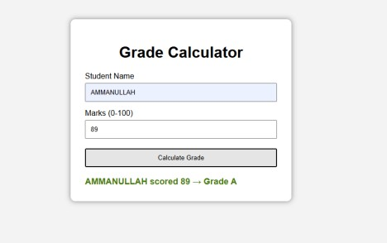
Part B: Assignment (15 Marks)
Complete all four questions. Each one goes in its own sub-folder inside assignment/ with its own HTML, CSS
and JS files.

Q1. Temperature Converter (4 marks)
- Write a function celsiusToFahrenheit(c) that returns (c * 9/5) + 32.
- Also write fahrenheitToCelsius(f) as an arrow function.
- Add one input and two buttons (&quot;To °F&quot; and &quot;To °C&quot;). Show the answer on the page rounded to 1 decimal place (hint: .toFixed(1)).
- Show a message if the input is empty or not a number.
CODE :

Index.html
<!DOCTYPE html>
<html lang="en"> <head>
<meta charset="UTF-8">
<meta name="viewport" content="width=device-width, initial-scale=1.0">
<title>Temperature Converter</title>
<link rel="stylesheet" href="style.css">
<script src="app.js" defer></script>
</head>
<body>
<div class="container">
<h1>Temperature Converter</h1>
<input type="number" id="temperature" placeholder="Enter temperature">
<button id="toFahrenheit">To °F</button>
<button id="toCelsius">To °C</button>
<div id="result"></div>
</div>
</body>
</html>

Style.css
body { font-family: Arial, sans-serif;
background-color: #f2f2f2; padding: 40px;
}
.container { width: 400px; margin: auto; background-color: white; padding: 30px;
text-align: center;
border-radius: 10px; box-shadow: 0 0 10px gray;
}
input { width: 90%;
padding: 10px;
}
button { padding: 10px 15px;
margin: 15px 5px;
cursor: pointer;
}
#result { margin-top: 20px; font-weight: bold;
}

App.js
function celsiusToFahrenheit(c) { return (c * 9 / 5) + 32;
}
const fahrenheitToCelsius = (f) => { return (f - 32) * 5 / 9;
};
document.getElementById("toFahrenheit").addEventListener("click", function () {
const value = document.getElementById("temperature").value; const result = document.getElementById("result");
if (value === "" || isNaN(Number(value))) { result.textContent = "Please enter a valid temperature.";
return;
}
const answer = celsiusToFahrenheit(Number(value)); result.textContent = `${answer.toFixed(1)} °F`;
});
document.getElementById("toCelsius").addEventListener("click", function () { const value = document.getElementById("temperature").value; const result = document.getElementById("result");
if (value === "" || isNaN(Number(value))) { result.textContent = "Please enter a valid temperature.";
return;
}
const answer = fahrenheitToCelsius(Number(value)); result.textContent = `${answer.toFixed(1)} °C`;
});
OUTPUT :
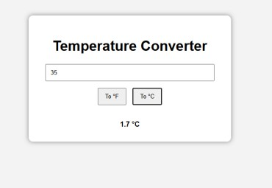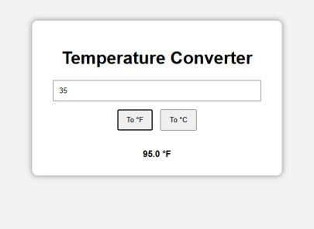

Q2. FizzBuzz List (4 marks)
- Use a for loop from 1 to 30 and add each item to a &lt;ul&gt; on the page. • Multiples of 3 show Fizz, multiples of 5 show Buzz, multiples of both show FizzBuzz. Use the % operator.
- Add an input so the user can choose the upper limit (e.g. 50) and a button to regenerate the list. CODE :

Index.html
<!DOCTYPE html>
<html lang="en"> <head>
<meta charset="UTF-8">
<meta name="viewport" content="width=device-width, initial-scale=1.0">
<title>FizzBuzz</title>
<link rel="stylesheet" href="style.css">
<script src="app.js" defer></script>
</head>
<body>
<div class="container">
<h1>FizzBuzz</h1>
<input type="number" id="limit" placeholder="Enter upper limit"> <button id="generateBtn">Generate</button>
<ul id="list"></ul>
</div>
</body>
</html>

Style.css
body { font-family: Arial, sans-serif;
background-color: #f2f2f2; padding: 40px;
}
.container { width: 400px; margin: auto; background-color: white; padding: 30px; border-radius: 10px; box-shadow: 0 0 10px gray;
}
h1 { text-align: center;
}
input { width: 100%; padding: 10px; box-sizing: border-box;
}
button { width: 100%;
padding: 10px;
margin-top: 15px;
} li {
margin: 5px;
}

App.js
function generateFizzBuzz() { const limit = Number(document.getElementById("limit").value); const list = document.getElementById("list"); list.innerHTML = "";
if (limit <= 0 || isNaN(limit)) { list.innerHTML = "<li>Please enter a valid number.</li>"; return;
}
for (let i = 1; i <= limit; i++) { let text;
if (i % 3 === 0 && i % 5 === 0) { text = "FizzBuzz";
} else if (i % 3 === 0) { text = "Fizz";
} else if (i % 5 === 0) { text = "Buzz";
} else { text = i;
}
list.innerHTML += `<li>${text}</li>`;
}
}

document.getElementById("generateBtn").addEventListener("click", generateFizzBuzz);
OUTPUT :
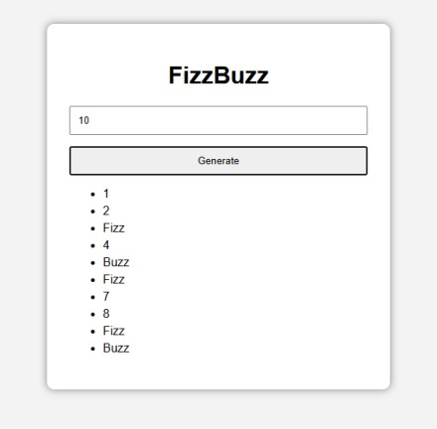

Q3. Student Records with Arrays &amp; Objects (4 marks)
- Create an array of 5 student objects, each with name, rollNo and marks.
- Use a loop to display all students in an HTML table (Name, Roll No, Marks, Grade). Reuse your grade logic from Part A as a function.
- Below the table, show the class average and the name of the top scorer. const students = [
{ name: &quot;Ayesha&quot;, rollNo: &quot;FSWD-01&quot;, marks: 88 },
{ name: &quot;Ali&quot;, rollNo: &quot;FSWD-02&quot;, marks: 74 },
// add 3 more students
];
CODE :

Index.html
<!DOCTYPE html>
<html lang="en"> <head>
<meta charset="UTF-8">
<meta name="viewport" content="width=device-width, initial-scale=1.0">
<title>Student Records</title>
<link rel="stylesheet" href="style.css">
<script src="app.js" defer></script>
</head>
<body>
<div class="container">
<h1>Student Records</h1>
<button id="sortBtn">Sort by Marks</button>
<table>
<thead>
<tr>
<th>Name</th>
<th>Roll No</th>
<th>Marks</th>
<th>Grade</th>
</tr>
</thead>
<tbody id="studentTable"></tbody>
</table>
<div id="average"></div>
<div id="topScorer"></div>
</div>
</body>
</html>

Style.css
body { font-family: Arial, sans-serif;
background-color: #f2f2f2; padding: 30px;
}
.container { max-width: 800px; margin: auto; background-color: white; padding: 25px;
border-radius: 10px; box-shadow: 0 0 10px gray;
}
h1 { text-align: center;
}
button { padding: 10px 15px;
margin-bottom: 15px;
cursor: pointer;
}
table { width: 100%;
border-collapse: collapse;
}
th, td {
border: 1px solid gray;
padding: 10px;
text-align: center;
}
th {
background-color: #ddd;
}
#average,
#topScorer { margin-top: 15px; font-weight: bold;
}

App.js
const students = [
{ name: "Ayesha", rollNo: "FSWD-01", marks: 88 }, { name: "Ali", rollNo: "FSWD-02", marks: 74 }, { name: "Ahmed", rollNo: "FSWD-03", marks: 92 }, { name: "Sara", rollNo: "FSWD-04", marks: 67 }, { name: "Usman", rollNo: "FSWD-05", marks: 81 } ];
function getGrade(marks) { if (marks >= 85) { return "A";
} else if (marks >= 70) {
return "B";
} else if (marks >= 50) { return "C";
} else { return "F";
}
}

function displayStudents() { const table = document.getElementById("studentTable");
table.innerHTML = "";
for (const student of students) { table.innerHTML += ` <tr>
<td>${student.name}</td>
<td>${student.rollNo}</td>
<td>${student.marks}</td>
<td>${getGrade(student.marks)}</td>
</tr>
`; } let total = 0;
for (const student of students) { total += student.marks;
}
const average = total / students.length; let topScorer = students[0];
for (const student of students) { if (student.marks > topScorer.marks) { topScorer = student;
}
}

document.getElementById("average").textContent =
`Class Average: ${average.toFixed(1)}`;
document.getElementById("topScorer").textContent =
`Top Scorer: ${topScorer.name}`;
}
function sortStudents() { students.sort((a, b) => b.marks - a.marks); displayStudents();
}
document.getElementById("sortBtn").addEventListener("click", sortStudents); displayStudents();
OUTPUT :
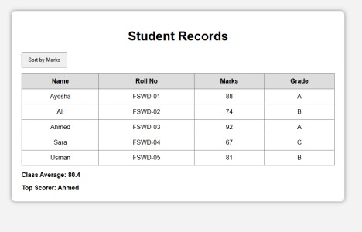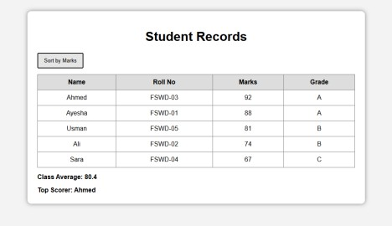

Q4. Click Counter with Theme Switcher (3 marks)
• Build a counter with three buttons: +1, −1 and Reset. The count must never go below 0. • Add a Dark Mode button that toggles a dark class on the &lt;body&gt; using classList.toggle(), and changes its own label to &quot;Light Mode&quot; / &quot;Dark
Mode&quot;. CODE :

Index.html
<!DOCTYPE html>
<html lang="en"> <head>
<meta charset="UTF-8">
<meta name="viewport" content="width=device-width, initial-scale=1.0">
<title>Counter and Theme</title>
<link rel="stylesheet" href="style.css">
<script src="app.js" defer></script>
</head>
<body>
<div class="container">
<h1>Counter</h1>
<div id="count">0</div>
<button id="plusBtn">+1</button>
<button id="minusBtn">-1</button>
<button id="resetBtn">Reset</button>
<br>
<button id="themeBtn">Dark Mode</button> </div>
</body>
</html>

Style.css
body { font-family: Arial, sans-serif;
background-color: #f2f2f2; color: #222;
padding: 40px;
transition: 0.3s

;
}
.container { width: 400px; margin: auto; text-align: center; background-color: white; padding: 30px; border-radius: 10px;
}
#count { font-size: 50px; margin: 20px;
}
button { padding: 10px 15px;
margin: 5px;
cursor: pointer;
}
.dark { background-color: #222; color: white;
}
.dark .container { background-color: #333;
}

App.js
let count = 0;
function updateCount() { document.getElementById("count").textContent = count;
}
document.getElementById("plusBtn").addEventListener("click", function () { count++; updateCount();
});
document.getElementById("minusBtn").addEventListener("click", function () {
if (count > 0) { count--;
}
updateCount();
});
document.getElementById("resetBtn").addEventListener("click", function () { count = 0; updateCount();
});
document.getElementById("themeBtn").addEventListener("click", function () { document.body.classList.toggle("dark");
if (document.body.classList.contains("dark")) { this.textContent = "Light Mode";
} else { this.textContent = "Dark Mode";
}
});
OUTPUT :
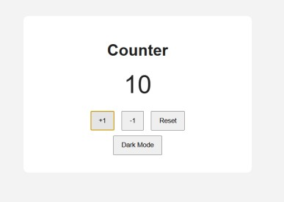
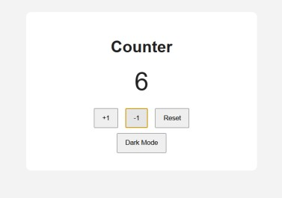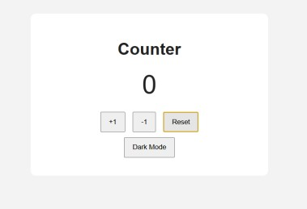
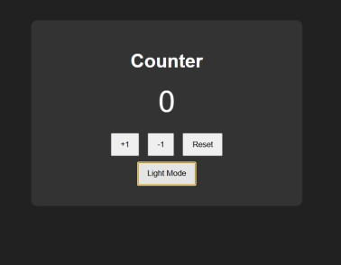
GITHUB LINK :
ALL FILES IN ONE
FOLDER :
